sudo curl -L "https://github.com/docker/compose/releases/download/$(curl -s https://api.github.com/repos/docker/compose/releases/latest | jq -r .tag_name)/docker-compose-$(uname -s)-$(uname -m)" -o /usr/local/bin/docker-compose

sudo apt-get install jq

sudo chmod +x /usr/local/bin/docker-compose

docker-compose –version

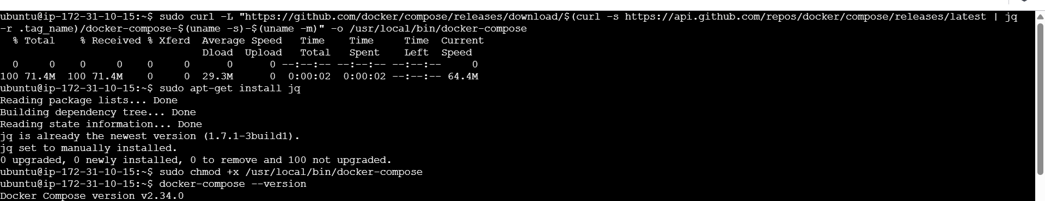

Docker-compose.yml

version: '3.8'

services:

jenkins:

image: jenkins/jenkins:lts-jdk17

container_name: jenkins_container

ports:

- "8090:80"

- "50000:50000"

volumes:

- my_jenkins:/var/jenkins_home

restart: always

tomcat:

image: tomcat:latest

container_name: tomcat_container

ports:

- "8080:8080"

volumes:

- my_tomcat:/usr/local/tomcat

restart: always

volumes:

my_jenkins:

my_tomcat:

Command: docker-compose up -d

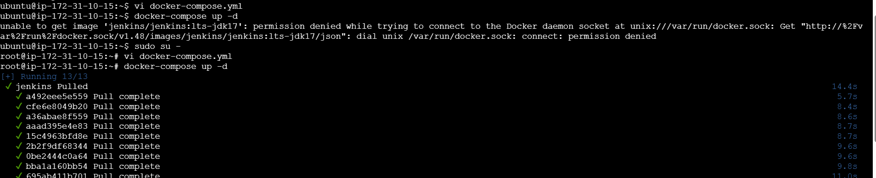

Docker-compose ps

Docker volume ls

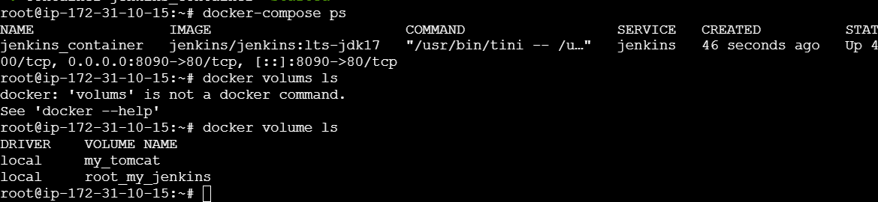

Docker-compose down

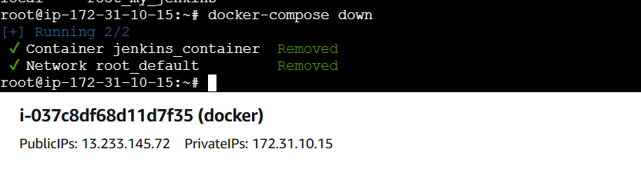

Docker ps:

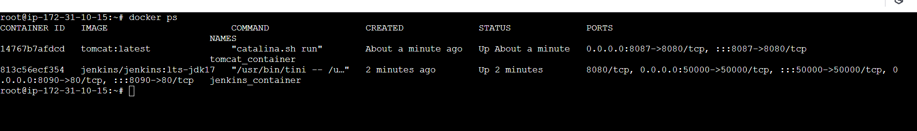

Docker compose 1 tier application

Github link: https://github.com/docker/awesome-compose

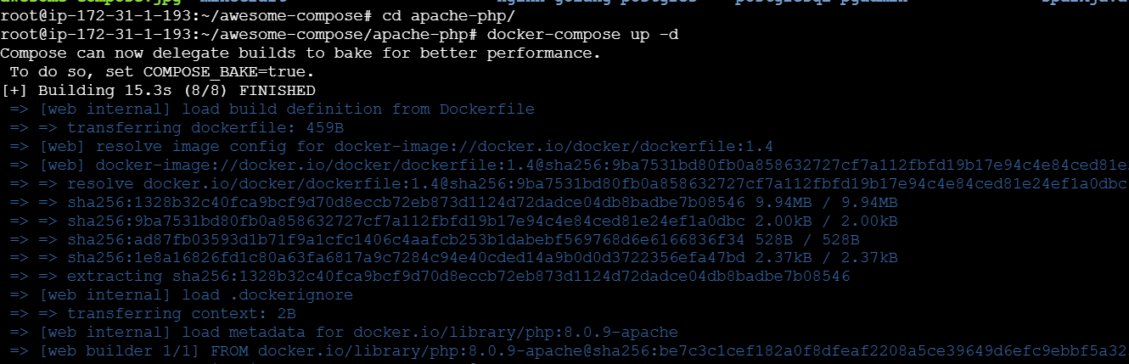

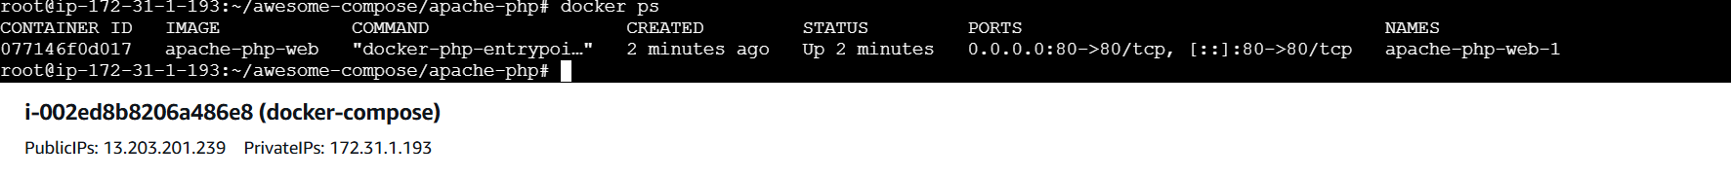

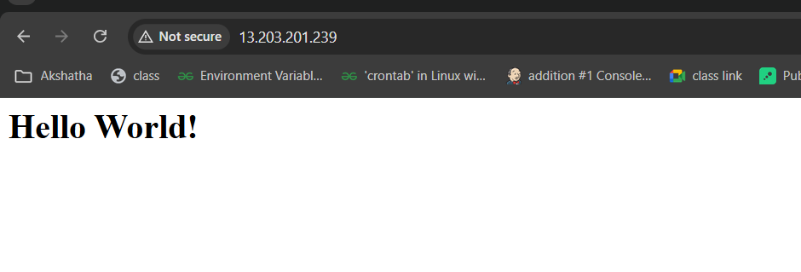

Docker compose 2 tier application:

